# What is ECG?

An ECG (Electrocardiogram) is a paper or digital recording that displays electrical signals in the heart as an endless polyline. It is also called an EKG. The ECG can be used to determine heart rate, heart rhythm and information on user’s medical status based on them. ECGs are extremely effective in diagnosing and predicting heart arrhythmias, heart attacks and heart failure. (Anon., n.d.)

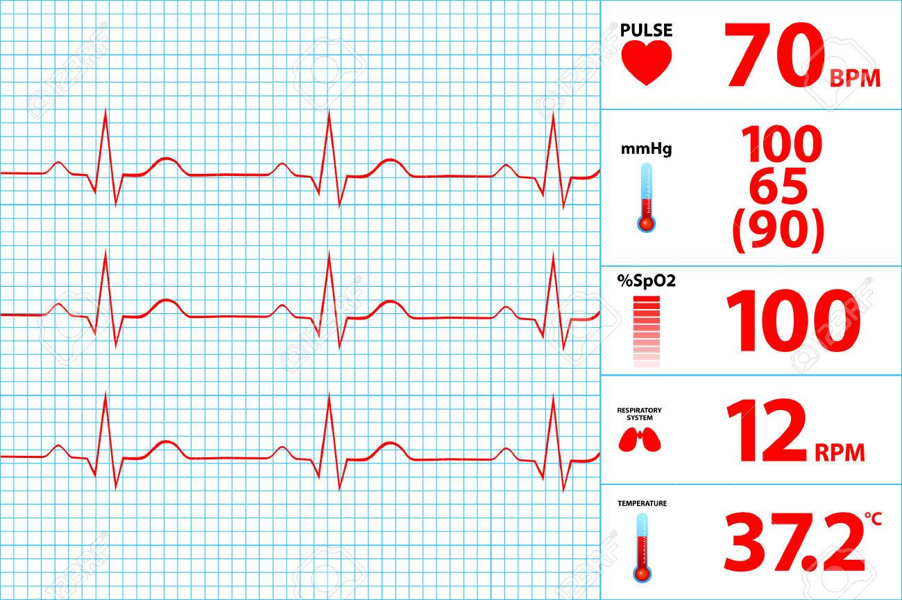

Figure : Electrocardiogram and its basic information

# Smart home device

Smart home devices are the components of an automated home. Home are automated in order to improve user’s convenience, experience, health, behavior and security.

A smart home device bundle often consists of functional devices that is attached to the house or the human himself and a controller which can be a smart watch, phone or tablet. User can interact with functional devices by normal interaction with the controller (touching, clicking) or by using voice. Nowadays, some smart home devices are able to learn from user’s behavior to work more efficient. (Rouse, n.d.)

# Idea analysis

With the rapid development of smart home systems, it can be very effective to apply smart home technologies for health care. Heart rate is one of the most important section of medical matters, especially for elders, who are the main subject of the smart home as they are at home most of the time, vulnerable and dull. That is where the idea of a smart home device with ECG integration begins.

In all type of controller, smartphone shows that it is most suitable for the scenario because of the following reasons:

## Convenience

Nowadays, the sensors that are used along with smartphone ECG apps are not necessary attached to the phone, it can be a portable case that we put our finger on, or a smart watch that is connected to the smartphone.

Both the sensor and the smartphone itself can be very small and portable, which we can bring anywhere to checkout our heart’s performance anytime.

Even though the smartphone is small, it has enough memory to store your measurements’ history and keep your heart’s status on track so that you can consult a doctor in time and adjust your treatment. You can also use the smartphone to contact your doctor easily by calling or texting, this feature can also be integrated directly into the app. (Letter, 2016)

## High accuracy

In 2014, one of the most popular brand of ECG apps, AliveCor Kardia Mobile Heart Monitor, was approved by FDA and many other reputable organizations. Since then, many others similar products are also medically approved, which means the results of ECG smart home devices are getting closer and closer to the correct result of traditional measurements. (Letter, 2016)

## Various ways to detect afib

Atrial fibrillation (afib) – a rapid, irregular heart rhythm that raises the risk of stroke - a serious issues when it comes to heart’s health. An afib is very hard to detect because it only lasts for a few minutes and some cases the patient have no symptoms at all. It is very hard for an ECG to detect an afib if it is not automated and scheduled. Research also shows that traditional methods might misunderstood many heart’s reaction with an afib such as reaction with a finger slip.

That is when we need a smart home device to solve the problem, not only has an effective automated feature, a smartphone also surprisingly provide many ways to detect afib with camera (measures color changes in the light reflected from the blood in your finger) or its own gyroscope and accelerometer. (Letter, 2016)

# Available products on the market

Here are some popular ECG smart health devices using smartphone app on the market:

## Kardia

Kardia is the signature product of AliveCor Company, an ancient company with high reputation and recognition. As a result, it is the most clinically validated mobile ECG solution on the market.

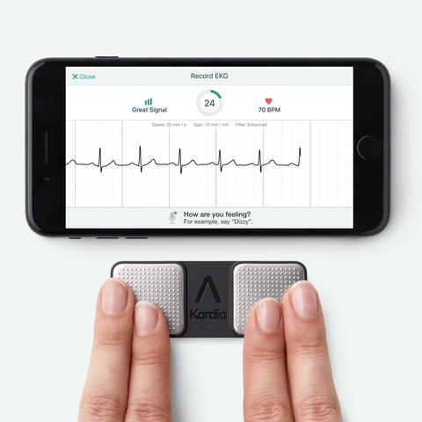

Figure : Kardia application for ECG solution

Kardia provide you rich information from reputable organizations after analyzing your result. You can also send your result to cardiologists which are AliveCor’s partners for further clinical review.

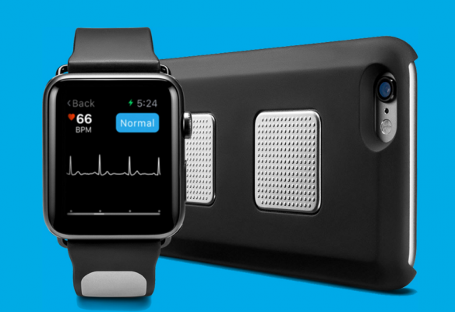

Figure : KardiaBand and KardiaMobile

You can use KardiaMobile or KardiaBand to record your ECG. KardiaMobile uses a quite old-fashioned sensor, it is a small bar with two places to put and hold your finger on which can be attached to the case or separated completely. You can take the test anywhere, anytime with just only 30 seconds. Meanwhile, KardiaBand use a device that is wrapped around your wrist which is similar to a smart watch. KardiaBand also provide the SmartRhythm workout monitoring system which takes your heart rate and activity data gathered from the Apple Watch during workouts. (Store, n.d.)

## Qardo

Not as old and reputable as Kardia, but Qardo’s products are becoming high-end model for modern ECG solution. 2017 is an explosion for Qardo Company with many awards for its darling product. Similar to Kardia, Quardo allows you to record ECG remotely and get information from the experts to analyze and validate your results, it can also be used during your workout.

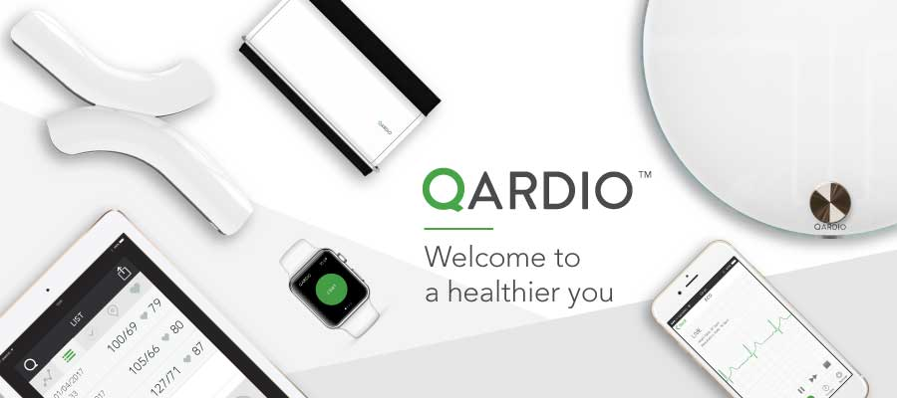

Figure : Qardio and its various types of sensor

Quardo also allows users to connect with cardiologists, but its data sharing system expand to a larger network, you can also share your data with your friends or family to get more supports.

Qardo has many ways to record ECG, two of the most popular products are QardoArm (use a band wraps around the wrist) and QardoCore (use a sensor wraps around the core). Generally, it is easier to record ECG with Qardo, it often takes only one click, the analysis information is also easier to understand with many smart charts, stats and trends, set up goals and reminders. (Anon., n.d.)

## Conclusion

Both products above has basic requirements of an ECG solution: allows user to record ECG, gather and analysis results, connect with cardiologists for review and treatment. Nonetheless, there are still some they lack of the ability to alert users and make an emergency call for help when there is a serious problem. That feature is what should be add to this product to improve the ECG solution.

# Course work

## General requirements

* A concept of ECG smart home device using mobile app.
* Have at least two types of interactions.
* Prototype and user manual.

## Functionalities

The program will have these functionalities:

* Recording ECG through the integrated sensor.
* Connect and transfer data to the smartphone
* Save/display measure history on the smartphone.
* Give advice, warn the user about the risk based on measure results.
* Save information of cardiologists and doctors and be able to use emergency calls.

## Audiences

The target audience of this health device is only the patient, which is default user. This device will act as a medical support equipment for individual that provides data by ECG to support their medical treatment process or just for better healthcare.

## Use-Case

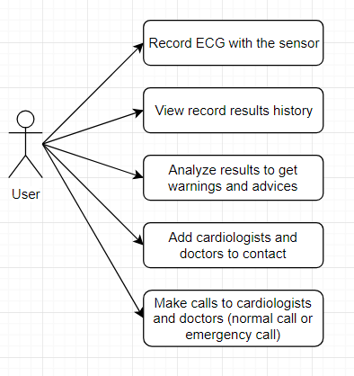

Figure : device's use case diagram for user

There is only one user target with five interactions with the device as the figure displays. Nonetheless, there are two automated functions of the device: automatically store ECG record into database and automatically alert users if their hearts are in danger status.

# References

Anon., n.d. *Electrocacrdiogram-ecg.* [Online]   
Available at: https://www.mydr.com.au/tests-investigations/electrocardiogram-ecg

Anon., n.d. *Qardio heart health on App Store.* [Online]   
Available at: https://itunes.apple.com/vn/app/qardio-heart-health/id855275752?l=vi&mt=8

Letter, H. H., 2016. *Monitoring your heart rhythm with a smartphone: A good call? - Harvard Health.* [Online]   
Available at: https://www.health.harvard.edu/heart-health/monitoring-your-heart-rhythm-with-a-smartphone-a-good-call

Rouse, M., n.d. *What is smart home or building (home automation or domotics)? - Definition from WhatIs.com.* [Online]   
Available at: https://internetofthingsagenda.techtarget.com/definition/smart-home-or-building

Store, K. o. t. A., n.d. [Online]   
Available at: https://itunes.apple.com/us/app/kardia/id579769143?mt=8